PROJECT REPORT

ON
“Synthesis and mechanical characterization of Al-
Si/Al₂O₃-TiB₂ Hybrid Metal Matrix Composite”



Department of Metallurgical and Materials Engineering Indira Gandhi Institute of Technology,
Sarang ,759146
(An autonomous institute of govt. of Odisha)
(2025-2026)

“Synthesis and mechanical characterization of Al-Si/Al2O3-TiB2 Hybrid Metal Matrix Composite”

A thesis submitted in partial fulfilment of the requirements for the award of the degree of Bachelor of Technology
In

METALLURGICAL AND MATERIALS ENGINEERING



Under the guidance of: Submitted by: Registration No:
Abhilas Das 2201105486
Josef Kumar Jena 2201105507

Raj Kumar Toppo 2201105520

Sruti Sikha Pradhan 2201105531

Ashish Sahoo 2321105113

Dr. Sandeep Kumar Sahoo
(Assistant professor)
&
Mr. Aditya Prasad Sahoo
(Guest Faculty) Department of metallurgical and materials engineering

Department of Metallurgical and Materials Engineering Indira Gandhi Institute of Technology, Sarang,759146
(An autonomous institute of govt. of Odisha) (2025-2026)


DEPARTMENT OF METALLURGICAL AND MATERIALS ENGINEERING

INDIRA GANDHI INSTITUTE OF TECHNOLOGY, SARANG

Certificate
This is to certify that the thesis entitled “Synthesis and mechanical characterization of Al-Si/Al2O3-TiB2 Hybrid Metal Matrix Composite” submitted by names and regd no. Abhilas Das, Josef Kumar Jena, Raj Kumar Toppo, Sruti Sikha Pradhan, Ashish Sahoo 2201105486, 2201105507, 2201105520,2201105531 and 2321105113 respectively in partial fulfilment of the requirements for the award of the Degree of Bachelor of Technology in Metallurgical and Materials Engineering during the academic year 2025-2026 is a Bonafide record of work/research carried out by them under our supervision. The content of this report/dissertation, in the full or parts has not been submitted to any other institute or university for the award of any degree or diploma.

Supervisor
Dr. Sandeep Kumar Sahoo
(Assistant professor)
Department of metallurgical
&
materials engineering
Co- Supervisor
Mr. Aditya Prasad Sahoo
(Guest Faculty)

Head of Department Dr. Swarnalata Behera
Department of metallurgical &
materials engineering
External Examiner

ACKNOWLEDGEMET
It is with a feeling of great pleasure that e would like to express our most sincere heartfelt gratitude to Dr. Sandeep Kumar Sahoo, Assistant Professor, Department of Metallurgical and Materials Engineering, IGIT Sarang & Mr. Aditya Prasad Sahoo, Guest Faculty, Department of Metallurgical and Materials Engineering, IGIT Sarang for suggesting the topic for our thesis report and for their ready and able guidance throughout the course of our preparing the report. We are greatly indebted to them for their constructive suggestions from time to time during the course of progress of our work.
We feel our deep sense of gratitude to Dr. Swarnalata Behera, Head of the Department of Metallurgical and Materials Engineering, IGIT, Sarang, for allowing us to pursue our project and providing us the necessary facilities in the department.
We are thankful to all faculty members and staffs of the Department of Metallurgical & Materials Engineering, IGIT Sarang for always being a helping hand throughout our project here.
Last but not least We wish to acknowledge all who have been connected more or less with this venture and donated their valuable time.

Name: Registration No: Signature:
Abhilas Das 2201105486
Josef Kumar Jena 2201105507
Raj Kumar Toppo 2201105520
Sruti Sikha Pradhan 2201105531
Ashish Sahoo 2321105113
ABSTRACT

Aluminum–Silicon (Al–Si) based hybrid composites have attracted considerable interest as advanced engineering materials because of their excellent combination of low weight, high strength-to-weight ratio, good corrosion resistance, and superior wear properties. In this study, an Al–Si alloy matrix composite reinforced with both ceramic and solid lubricant particles is developed to enhance its mechanical and tribological performance, making it suitable for applications in the automotive and aerospace sectors.
The composite is prepared using the stir casting technique, which is widely preferred due to its simplicity, cost-effectiveness, and suitability for large-scale production. Reinforcements such as Aluminum oxide (Al2O3), Zinc Oxide (ZnO), and Titanium diboride (TiB2) are added to the aluminum matrix to achieve a balanced improvement in strength, toughness, and wear resistance.
Microstructural characteristics, including grain size, distribution of reinforcements, and morphology of silicon phases, play a crucial role in determining the overall properties of the composite. Experimental studies reported in the literature indicate that the incorporation of hybrid reinforcements leads to significant improvements in hardness, tensile strength, fracture toughness, and wear resistance compared to conventional aluminum alloys. However, an increase in reinforcement content may result in reduced ductility, highlighting the need for optimization of composition and processing parameters.

List of Table

Sl No | Table No. | Name of Table
1 | Table 1 | Characteristics of Aluminium
2 | Table 2 | Characteristics of Silicon
3 | Table 3 | Atomic data table
4 | Table 4 | Charge Calculation
5 | Table 5 | Density of Specimen
6 | Table6 | Hardness of Composites

List of Graph

Sl No | Graph No. | Name of Graph
1 | Graph 1 | Density of specimen
2 | Graph 2 | Hardness of specimen

List of Figure

Sl No | Figure No | Name of Figure
1 | Fig. 1 | Al- Si Binary phase diagram
2 | Fig. 2 | Fabrication process on HAMC
3 | Fig. 3 | Stir Casting
4 | Fig. 4 | Mould for Casting
5 | Fig. 5 | Al Ingot
6 | Fig. 6 | AL-Si Master alloy
7 | Fig. 7 | K₂TiF₆ & KBF₄
8 | Fig. 8 | Al Casting Preparation
9 | Fig. 9 | Cast Composite Sample
10 | Fig. 10 | Disc Polishing machine
11 | Fig. 11 | Metallurgical Microscope
12 | Fig. 12 | Vickers hardness testing Machine
13 | Fig. 13 | Density test Apparatus

1. INTRODUCTION 1-2
1.1. BACKGROUND
1.2. OBJECTIVE
1.3. RESEARCH APPROACH
1.4. OUTPUT AND DELIVERABLE
2. LITERATURE REVIEW 3-11
3. EXPERIMENTAL PROCEDURE 12-20
4. RESULT & DISCUSSION 21-26
4.1. DENSITY TEST
4.2. HARDNESS TEST
4.3. SEM TEST
5. CONCLUSION 27
6. REFERENCE 28

CHAPTER 1

INTRODUCTION

  - Background:

Aluminum is a silvery white, soft, ductile metal with symbol Al, atomic number 13, mass
26.98 and face center cubic crystal structure.
Aluminum is a versatile metal abundant in the Earth's crust. It is prized for its lightness, conductivity, corrosion resistance due to passivation, and to-weight aluminum is non- magnetic and has low which is about one third of the density of steel. Aluminum is a good thermal and electrical conductivity. components made from aluminum and its alloy are widely used in aerospace and transportation due to its exceptional properties.
Silicon is the 2nd most abundant element in the earth by making up to 25% of the crust. It rarely occurs as the pure in nature more widely appeared as compound. Most form is silica oxide. It has many industrial uses such as silicon is the principal component of semiconductor most importantly integrated circuits or computer chips. At temperature silicon exists in two forms. First one is amorphous (brown powder) and second one is crystalline (metallic luster and a greyish colour ).
Aluminum oxide (Al₂O₃), also known as alumina, is a very stable and commonly used ceramic material. It is usually found in nature as bauxite and corundum. Al₂O₃ is widely used in engineering applications because of its high hardness, excellent wear resistance, and good thermal stability. It also has high melting temperature and strong resistance to corrosion and oxidation. Due to these properties, Al₂O₃ is often used as a reinforcement material in metal matrix composites. It improves strength, hardness, and durability of the base metal. Additionally, it is used in abrasives, cutting tools, electrical insulation, and protective coatings.
Aluminium and its alloys, when reinforced with various materials like copper, zinc, manganese, silicon, or magnesium, are widely used in metal matrix composites (MMCs). These composites offer advantages such as lighter weight and better corrosion resistance compared to plain carbon steel. Additionally, alloys of aluminum reinforced with ceramic particles like oxides, carbides, nitrides, and mineral silicates exhibit high specific modulus, strength, and corrosion resistance. In wear resistance applications, aluminum-silicon alloys are common due to silicon's contribution to their wear resistance. Further enhancement in wear resistance can be achieved by incorporating reinforcements like in- situ TiB2 particles. While research has shown the beneficial effects of in-situ TiB2 particles, some studies indicate that excessive amounts can deteriorate wear behavior. Investigating the particle size distribution of TiB2, it's found that finer distributions lead to reduced third body wear.

Aluminium Metal Matrix Composites (MMCs) have gained significant importance as advanced engineering materials due to their low density, high strength-to-weight ratio, and good corrosion resistance. Aluminium alloys are widely used as matrix materials because of their lightweight nature, good ductility, and ease of processing, making them suitable for both research and industrial applications.
The properties of aluminium alloys can be further enhanced by reinforcing them with ceramic particles such as SiC, Al₂O₃, and TiB₂. These reinforcements improve the mechanical performance of the composites through mechanisms like grain refinement, increased dislocation density, and effective load transfer between the matrix and reinforcement. As a result, properties such as hardness, stiffness, and overall strength are significantly improved.
Stir casting is considered one of the simplest and most cost-effective methods for producing MMCs. The process involves three main steps:
- Melting the base metal matrix material.
- Introducing nano-sized reinforcement particles (such as SiC, TiC, or Al₂O₃) into the molten metal, followed by thorough stirring to achieve a uniform distribution.
- Pouring the mixture into a mould, where it cools and get solidifies into the required shape.
The key advantages of stir casting include its low cost, suitability for mass production, and the ability to incorporate a wide range of reinforcement materials.

  - Objective:
    - To synthesize Al–Si hypoeutectic alloy reinforced with in-situ TiB₂ particles.
    - To evaluate the mechanical property of the composite in terms of hardness.
    - To determine the density of the developed composite.
    - To study the microstructure of the composite.
    - To analyse the effect of TiB₂ reinforcement on the properties of the composite.
    - To assess the suitability of the composite for engineering applications.
  - Research approach:
The Al-Si composite was prepared by stir casting method. They were characterized through a series of test
  - Outputs and deliverables:
Our work focuses on exploring the potential applications of Al–Si–TiB₂ composite based on its improved properties.
The composite offers advantages like lightweight nature, better hardness, and good performance.it can be useful for cost-effective and high-performance engineering applications.

CHAPTER 2

LITERATURE REVIEW

CHARACTERISTICS OF ALUMINIUM:

Aluminium is a lightweight, silvery-white metal that is widely used in engineering applications due to its excellent combination of physical and mechanical properties. It is one of the most abundant elements in the Earth’s crust and is typically found in combined forms such as bauxite. Aluminium has a low density, which makes it highly suitable for applications where weight reduction is important. One of its most significant properties is its excellent corrosion resistance, achieved through the formation of a thin, protective oxide layer on its surface.
Structurally, aluminium has a face-centered cubic (FCC) crystal structure, which provides good ductility and formability. It is highly malleable and can be easily cast, rolled, and machined into different shapes. Aluminium also possesses good thermal and electrical conductivity, making it useful in heat exchangers and electrical applications. Additionally, it is non-toxic, non-magnetic, and non-sparking, which further enhances its suitability for a wide range of uses.
However, pure aluminium has relatively low strength. To overcome this limitation, it is often alloyed with elements such as silicon, copper, and manganese to improve its strength and hardness. These enhanced properties make aluminium alloys particularly valuable in aerospace, automotive, and structural applications.

Atomic symbol | Al
Atomic number | 13
Appearance | Silvery
density | 2.7 g/cm3
Melting point | 660ᵒc
Boiling Point | 2470ᵒc
Crystal structure | FCC
Table 1: Characteristics of aluminium

CHARACTERISTICS OF SILICON:
Silicon is an important metalloid widely used in engineering materials due to its unique combination of properties. It is naturally abundant in the Earth’s crust, mainly present in the form of silica and silicate minerals. Silicon exhibits a grey, shiny appearance and possesses relatively high melting and boiling points, making it stable at elevated temperatures. In its crystalline form, it has a well-ordered diamond cubic structure, which contributes to its strength and stability. Chemically, silicon has four valence electrons and forms strong covalent bonds, resulting in a rigid tetrahedral arrangement. It also

shows semiconducting behavior, which makes it valuable in electronic applications. Unlike most metals, silicon expands during solidification, which is an unusual but important characteristic. These properties make silicon highly useful in aluminium alloys, where it improves casting characteristics, hardness, and overall performance of the material.

Atomic symbol Si
Atomic number 14
Element category Metalloids
density 2.329 g/cm3
Melting point 1414ᵒc
Boiling Point 5909ᵒc
Table 2: Characteristics of Silicon

ALUMINIUM ALLOYS:

In recent years, aluminium alloys have gained significant importance in the automotive sector due to the increasing demand for weight reduction and improved fuel efficiency. These alloys are typically alloyed with elements such as copper (Cu), magnesium (Mg), manganese (Mn), silicon (Si), and zinc (Zn) to enhance their mechanical and physical properties.When exposed to atmospheric conditions, particularly in dry environments, aluminium alloys undergo rapid surface oxidation, resulting in the formation of a thin, stable, and adherent aluminium oxide (Al₂O₃) layer. This passive oxide film acts as a protective barrier, significantly improving corrosion resistance while also imparting a characteristic metallic luster to the surface.

PROPERTIES OF ALUMINIUM ALLOYS:
A wide range of physical and mechanical properties can be achieved from high-purity aluminium, making it suitable for diverse engineering applications.
Physical properties
    - Density ~2.70 g/cm³ (About one-third the density of steel)
    - Melting Point ~660 °C (1220 °F) (Relatively low melting point)
    - Boiling Point ~2470 °C (4478 °F)
    - Electrical Conductivity ~62% of copper (High electrical conductivity; more than double that of copper by weight)
    - Thermal Conductivity ~237 W/m·K (High thermal conductivity, about three times greater than steel)
    - Corrosion Resistance - Excellent (Forms a self-protecting oxide layer Al2O3).
    - Reflectivity (Visible Light) - Up to 80% High reflectivity.

    - Reflectivity (Infrared) - Up to 98% High reflectivity.
    - Ductility - High (Can be drawn into wires)
    - Malleability - High (Can be hammered or rolled into thin sheets)
    - Magnetic Permeability - Paramagnetic (weakly attracted) Surface Finish - Can be highly reflective
Mechanical properties:
    - Tensile Strength
    - h ~90 MPa (Relatively low for pure aluminium. Increased significantly by alloying)
    - Yield Strength - Low Increases with alloying
    - Modulus of Elasticity ~70 GPa (A measure of stiffness)
    - Shear Strength ~60 MPa
    - Hardness Soft Can be significantly improved by alloying.
    - Elongation at Break - High Indicates good ductility.

  - PHASE DIAGRAM OF ALUMINIUM-SILICON:
The aluminium–silicon (Al–Si) system is a binary eutectic system with very limited mutual solid solubility between aluminium and silicon. Silicon has very low solubility in aluminium at room temperature, with its maximum solubility occurring near the eutectic temperature.
The eutectic composition lies around 12–13 wt.% silicon, where the alloy solidifies at a nearly constant temperature. Based on silicon content, Al–Si alloys are classified into hypoeutectic, eutectic, and hypereutectic types. In hypoeutectic alloys, primary aluminium
(α-phase) forms first, followed by the eutectic mixture, while in hypereutectic alloys, primary silicon particles form prior to the eutectic reaction.

The microstructure of Al–Si alloys is strongly influenced by cooling conditions. In hypereutectic alloys, slow solidification leads to the formation of coarse and irregular primary silicon particles along with eutectic silicon in the aluminium matrix, which adversely affects ductility and machinability. In contrast, rapid cooling or suitable melt treatment refines both primary and eutectic silicon, resulting in a finer and more uniform microstructure. This refinement significantly improves mechanical properties such as strength, hardness, and ductility.

The fundamental phase transformation in the Al–Si system is the eutectic reaction, represented as: L → α + β

Aluminium–silicon alloys are among the most widely used casting materials in foundry practice, particularly in the production of automotive engine pistons, due to their excellent casting characteristics, wear resistance, and thermal stability.

Classification based on silicon content (wt.%):
- Hypoeutectic (12.6 wt. % Si)
- Eutectic (=12.6 wt. % Si)
- Hypereutectic (>12.6 wt. % Si)

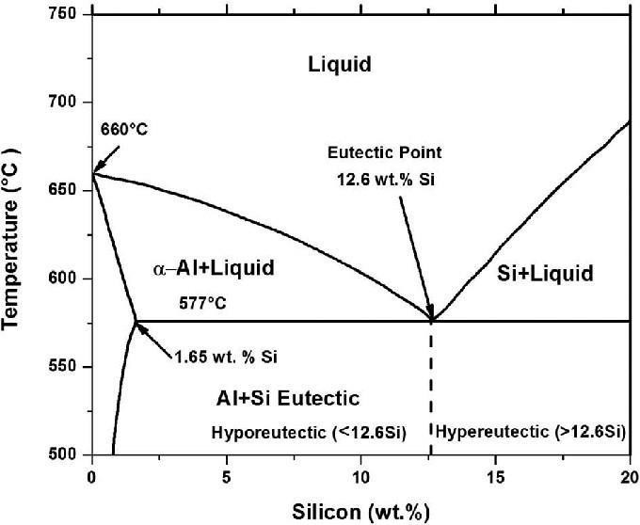
Fig 1: Al-Si binary phase diagram

COMPOSITE:
Composite materials are engineered by combining two or more distinct phases, typically a matrix and a reinforcement, to achieve properties that are superior to those of the individual constituents. In metal matrix composites (MMCs), a metal matrix such as aluminium is reinforced with materials like ceramics, including oxides (Al₂O₃, MgO), carbides (SiC, TiC, B₄C), nitrides (AlN, BN), and borides (TiB₂). The addition of these reinforcements significantly improves properties such as strength, stiffness, hardness, and overall performance. As a result, composites offer advantages like low density, high strength, good thermal stability, and enhanced corrosion resistance, making them suitable for advanced engineering applications.

CLASSIFICATION OF COMPOSITES:
Composite materials are commonly classified at following two distinct levels: -

Ceramic Matrix Composites (CMC):
Ceramics are solid materials primarily characterized by strong ionic bonding, although covalent bonding may also be present in some cases. They exhibit properties such as high melting temperatures, excellent corrosion resistance, thermal stability at elevated temperatures, and high compressive strength. These characteristics make ceramic-based matrix materials highly suitable for applications where structural integrity must be maintained at temperatures exceeding 1500°C. Therefore, ceramic matrices are widely preferred for high-temperature applications.

Metal Matrix Composites (MMCs):
Metal matrix composites are advanced engineering materials formed by combining a metallic matrix with reinforcing phases such as particles, fibers, or whiskers. This combination results in materials that exhibit enhanced properties compared to conventional monolithic metals, offering an optimized balance of strength, stiffness, low weight, and high-temperature capability. MMCs are particularly suitable for demanding applications due to their unique set of advantages. They exhibit improved mechanical performance, including higher specific strength (strength-to-weight ratio) and specific stiffness (stiffness-to-weight ratio) compared to unreinforced metals. In addition, MMCs demonstrate enhanced high-temperature performance, as they are able to retain their mechanical properties at elevated temperatures better than conventional alloys. Another significant advantage is their superior wear resistance, which is achieved through the incorporation of hard reinforcement phases that effectively resist abrasion and material degradation.

APPLICATION OF ALUMINIUM MATRIX COMPOSITE (AMCS):

- Aerospace in aircraft Industry:
Aluminium alloys and composites are integral to aircraft and rocket technology, used extensively in commercial airliners and spacecraft for their lightweight, high-strength properties. They have been crucial in aerospace advancements since the Wright brothers, offering mechanical stability and weight reduction for structures like space shuttles and the International Space Station.

- Rail Transport:
Aluminium rail cars, introduced in the late 1950s, offer significant weight savings, reduced fuel costs, and improved carrying capacity compared to steel cars. Examples include the French TGV Duplex and Japanese bullet trains, which achieved notable efficiency gains by transitioning to aluminium-based materials.

- Marine Transport:
Aluminium alloys and composites have revolutionized marine transport, enabling faster, more fuel-efficient vessels with increased load capacities and improved stability. Advances like friction-stir welding allow for the design of high-performance, agile ships for commercial and military applications.

- Building Construction:
Aluminium, once used for decorative purposes, is now a cornerstone of sustainable building materials. With 85% sourced from recycled material, its corrosion resistance and recyclability make it ideal for low-maintenance bridge decks and structural components, reducing energy consumption during recycling by over 90%.

PROCESSING ROUTE OF HYBRID COMPOSITE:

The selection of a suitable processing technique for Hybrid Aluminium Matrix Composites (HAMCs) depends on several factors, including the type of matrix and reinforcement, their mechanical and thermal properties, and the desired microstructure. Proper compatibility between the matrix and reinforcement, along with effective interfacial bonding and uniform distribution of particles, plays a crucial role in determining the final properties of the composite. HAMCs are generally fabricated using two main approaches: solid-state processing and liquid-state processing. The choice of method significantly influences key mechanical properties such as hardness, strength, fatigue resistance, and overall performance, as well as the cost-effectiveness of the composite material.


MATERIAL SELECTION
(Matrix, Reinforcement,Hybridization)
PRIMARY MIXING & BLENDING
mixing reinforcement with matrix, achieving uniform dispersion
LIQUID ROUTE
(Casting, Infiltration)
SOLID/SEMI- SOLID ROUTE
(Powder Metallurgy,Deformation)
SLURRY
PREPERATION
(matix +reinforcement)
POWDER
M
IXING/BALL
MILLING
(Homogenous powder blend)
SHAPING & CONSOLIDATION
(hand lay-up, spray- up,RTM,filament winding
,pultrusion)
COMPACTION
(Cold/hot pressing,isostatic pressing)
CURING/ SOLIDIFACTION
SINTERING/ CONSOLIDATON
(high temperature bonding,sparplasma sintering)
SECONDARY PROCESSING
(extrusion,rolling,forging,machining,joi ning)
POST-PROCESSING
(heat treatment,surface modification,finishing)
FINAL HYBRID COMPOSITE PRODUCT
(testing, evaluation, application)

Figure 2: - Fabrication process on HAMC

MASTER ALLOY:
A master alloy is a pre-alloyed combination of a base metal such as aluminium with small amounts of alloying elements like Sr, Ti, or Mg, which are difficult to add in pure form.
These master alloys are easier to handle, more cost-effective, and ensure better and uniform distribution of alloying elements in the melt, even when added in very small quantities. They also dissolve more efficiently in the molten metal compared to pure elements.
Silicon plays an important role in Al–Si alloys by reducing thermal expansion and slightly affecting the lattice structure of aluminium. It also improves certain properties but increases hardness, which can make machining more difficult. Overall, the presence of silicon significantly influences the physical and mechanical behaviour of aluminium alloys.

RAINFORCEMENT MATERIAL:
Reinforcement from metal matrix composite have a manifold demand profile which is determined by production, processing, and by the matrix system of the composite material.

- TiB2: Titanium diboride (TiB₂) is a hard ceramic reinforcement widely used in aluminium composites due to its excellent thermal stability, wear resistance, and good wettability with molten aluminium. It is often synthesized in-situ using chemical reactions involving salts such as KBF₄ and K₂TiF₆, where proper control is necessary to avoid the formation of undesirable phases like Al₃Ti. TiB₂ is preferred because of its strong compatibility with aluminium and its ability to remain stable in the melt. TiB₂ plays a key role in improving the microstructure of aluminium alloys by acting as an effective grain refiner. It provides nucleation sites at the matrix–particle interface, leading to finer and more uniform grain structure. This results in enhanced mechanical properties such as increased hardness, strength, and improved corrosion resistance. Strengthening mechanisms like dislocation pinning and grain boundary strengthening further contribute to the improved performance of Al–Si–TiB₂ composites, making them suitable for demanding engineering applications.

- Al2O3: Alumina (Al2O3) is a widely used and cost-effective ceramic material known for its high strength, oxidation resistance, hardness, and wear resistance. It's commonly found in purity ranges from 95% to 99.8%, making it suitable for high- temperature applications. In various studies, the incorporation of Al2O3 particles in metal matrix composites (MMCs) has been observed to improve corrosion resistance and promote adequate bonding between the matrix and reinforcements. The presence of Al2O3 particles enhances corrosion resistance, reduces defects, and offers safety to the softer matrix, thereby improving wear resistance and reducing surface sliding. Additionally, Al2O3 acts as a barrier against plastic deformation of the matrix, leading to improved wear resistance. In hybrid aluminum matrix metal composites (HAMMCs), Al2O3 serves as an effective reinforcement material due to its inertness in aluminum matrices, high inter-atomic bonding, and suitability for high-temperature applications. Incorporating Al2O3 in HAMMCs enhances wear resistance and

mechanical properties like tensile strength and micro-hardness. Though, there are numerous choices of reinforcement materials TiB2 and Al2O3 are the ideal choices of increase the wear resistance properties.

STIR CASTING:
Stir casting is a widely used and economical method for the fabrication of Aluminium Matrix Composites (AMCs) and Hybrid Aluminium Matrix Composites (HAMCs). In this process, aluminium is melted and mixed with reinforcement particles through mechanical stirring to achieve a fairly uniform distribution. However, when molten aluminium is exposed to air, it forms a thin oxide layer (Al₂O₃), and continuous stirring increases oxidation, which can reduce wettability and make uniform dispersion of particles difficult.
To overcome this issue, wetting agents such as K₂TiF₆, borax, and magnesium are added to the melt. These additives help reduce oxidation and improve the wettability between the molten aluminium and reinforcement particles. As a result, better bonding and more uniform distribution of reinforcements are achieved, leading to improved composite properties.
10 𝐴𝑙 + 3 𝐾2𝑇𝑖𝐹6 + 6 𝐾𝐵𝐹4 → 3 𝑇𝑖𝐵2 + 9 𝐾𝐴𝑙𝐹4 + 𝐾3𝐴𝑙𝐹6

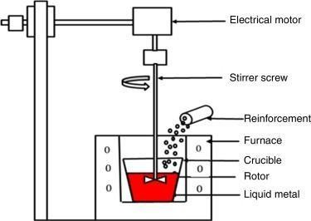

Fig 3: Stir casting

CHAPTER 3 EXPERIMENTAL PROCEDURE

  - Aims and Objectives:
From the literature review the following aims and objective are suggested to be carried out:
    - Synthesis of Al-Si alloys with 2 and 3 wt% in-situ TiB2 and 0.5-1 wt% Al2O3 through salt metal reaction using stir casting method
  - : Mould Dimension
    - Breadth – 12mm
    - Width – 9mm
    - Specimen size -16mm
    - Height -50mm
    - Base-16mm

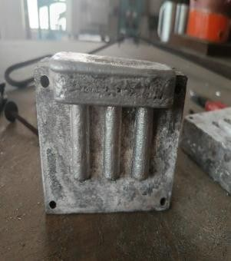
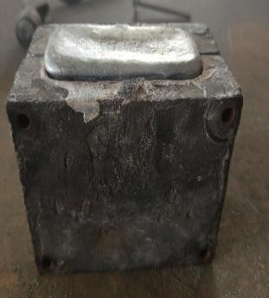
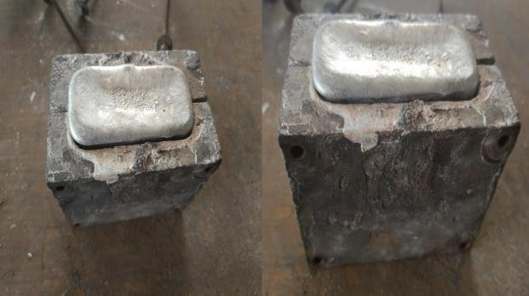
Figure 4: Mould for casting

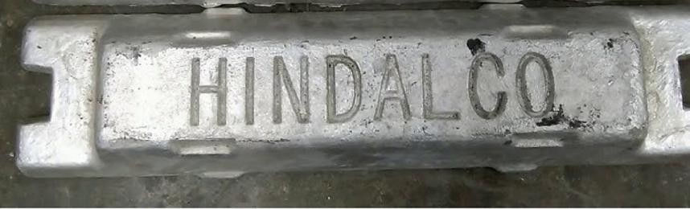

Figure 5: Aluminium Ingot of purity 99.9%

CHARGE CALCULATION:

Element | Atomic num. | Atomic mass
B | 5 | 10.81
F | 9 | 18.998
K | 19 | 39.09
Ti | 22 | 47.9
O | 8 | 15.999
AL | 13 | 26.982

Table 3 :- Atomic data table
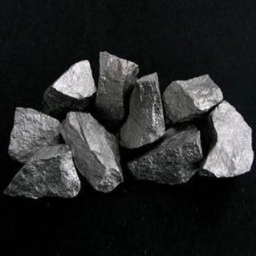

Figure 6: - Al-Si Master Alloy

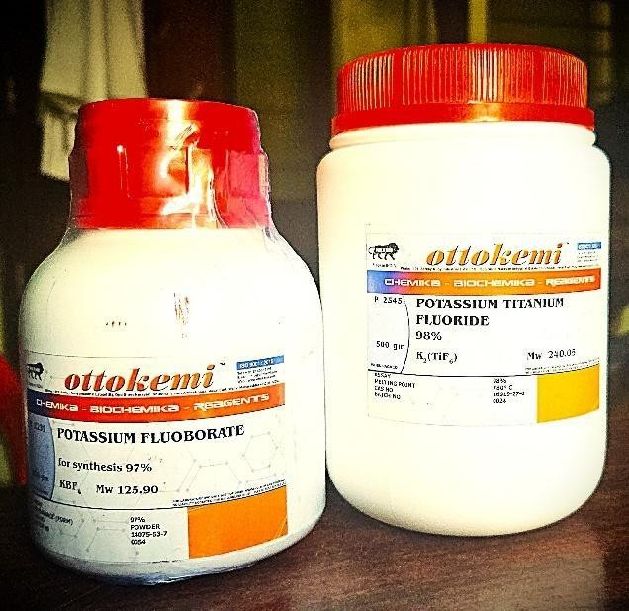

Figure 7: - K2TiF6 and KBF4

Molecular weights:

TiB2 = 47.9 + (2×10.81)=69.52 gm.
K2TiF6 = (2 * 39.09) + 47.9 + (6 * 18.998) = 240.068gm.
KBF4= 19.09 + 10.81 + (4 * 18.998) = 125.892 gm.
For Al-15Si-1Al2O3-2TiB2,
TiB2 require (2%) = 2/100 × 450 = 9gm Total AMC = 450 gm
Al + Al-50 Si+ Al2O3+TiB2=450gm Al+Al-50 Si+Al2O3= 450-9 =441gm
Al2O3 required (1%)=1/100×450=4.5gm
Si required(15%),
15/100 × 450 = 67.5 gm
Only source of Si is from master alloy
So, Total master alloy required 2 × 67.5=135 gm Al present in 135gm of master alloy is 67.5gm So total pure Al requires=441-4.5-135=301.5gm

Now K2TiF6 + 2KBF4 = TiB2 + slag
69.52gm of TiB2 is produced from 240.068 gm of K2TiF6
9 gm of TiB2 is produced from,
240.068/69.52 × 9 = 31.07gm
Loss = 20%
Total K2TiF6 required after adding loss = 37.284gm Similarly, from 2KBF4
9 gm of TiB2 is produced from,
(2×125.892)/69.52 ×9 = 32.596 gm
Loss = 20%
Total KBF4 required after adding loss = 39.115gm

In the same way, we determine the weight of creating each additional sample listed in the table below.
Alloy | Pure Al  (in gm) | Master alloy  (Al-Si) | TiB2 salt  (in gm) | AL203
Al-15Si-1Al₂O₃2TIB2 | 301.5 | 135 | 9 | 4.5
Al-15Si-0.5Al2O3-2TiB2 | 303.75 | 135 | 9 | 2.25
Al-15Si-1.5Al2O3-2TiB2 | 299.25 | 135 | 9 | 6.75
Al-15Si-1Al2O3-3TiB2 | 297 | 135 | 13.5 | 4.5
Al-15Si-0.5Al2O3-3TiB2 | 299.25 | 135 | 13.5 | 2.25

Table 4: - Charge Calculation

MOULD PREPARATION:
A mould was fabricated from a cast iron block using CNC machining to ensure high dimensional accuracy, good surface finish, and repeatability of the test specimens. Cast iron was selected as the mould material due to its excellent thermal stability, good wear resistance, and ability to withstand repeated thermal cycling during casting operations.
The internal cavity of the mould was precisely machined according to the required specimen geometry, ensuring proper filling and uniform solidification of the molten metal. Adequate allowances were provided for shrinkage and machining to obtain defect-free cast samples.
For the present study, the salt metal route was selected for composite preparation due to its effectiveness in improving wettability between molten aluminium and reinforcement particles, reducing oxidation losses, and enhancing uniform dispersion of reinforcement within the matrix. This route also helps in minimizing clustering of particles and improves interfacial bonding in the final composite.

STIR CASTING:

Al-Si alloy melt was prepared by melting CP aluminium and master alloy at 850 C̊ superheat the melting furnace and the melt was held at the temperature range of 800°C- 830°C to attain homogeneous composition. A mixture of Potassium Hexa Fluoro Titanate (K2TiF6) and Potassium Tetra Fluoro Borate (KBF4) salts were added to the melt in appropriate ratio to favour the formation of TiB2 particles by an exothermic reaction between the molten alloy and Al2O3 salts are added. The melt was gently stirred for 10 mins (3 times each), after the addition of TiB2 salts. After 10 mins, Al2O3 was added and stirred for 5 mins (2 times each). After the formation of the TiB2 particles, the reaction by products, such as the slag containing KAIF4 and K3AlF6, rise to the top of the molten alloy and were removed by decanting the crucible. The molten composite was then poured into a preheated (450°C) cast iron mould for preparation of different test specimens.
The reaction mechanism taking place in the melt are:

10 𝐴𝑙 +3 𝐾2𝑇𝑖𝐹6 +6 𝐾𝐵𝐹4 → 3 𝑇𝑖𝐵2+9 𝐾𝐴𝑙𝐹4+𝐾3𝐴𝑙𝐹6

Apparatus required:
- Muffled furnace
- Electric furnace
- Stirring rod
- Permanent cast iron mould
- Emery papers
- Metallurgical microscope
- Grinding and disc polishing machine

Some picture that had been taken during the experiment

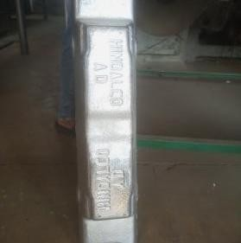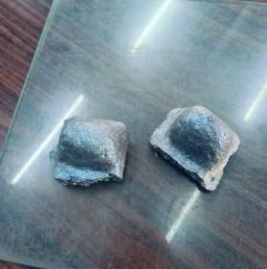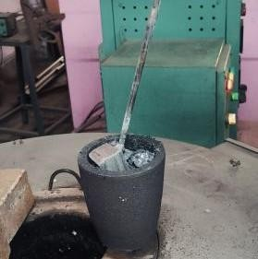

Fig 8: Aluminium ingot
Fig 8.1: Master Alloy Fig 8.2: Furnace

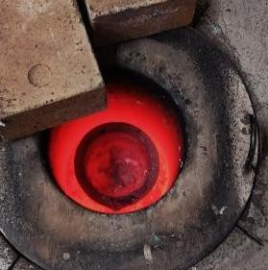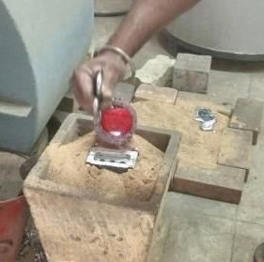
Fig 8.3: Oven Fig 8.4: Stirring Fig 8.5: Pouring into die
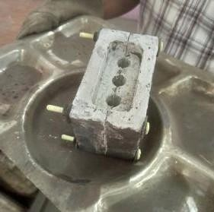
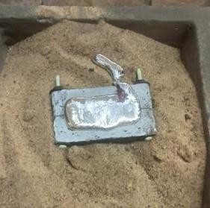
Fig 8.6: Mould Fig 8.7: Finishing product

SAMPLE PREPARATION:
Initially, Commercial pure aluminium (99.98%) and Al-Si Master alloy (50%Si) was melted in a graphite crucible in a muffle furnace after maintaining at a particular temperature (850℃) is reached. At the same time the die was prepared for casting purpose for which it was preheated to a temperature of 450℃ in an electric furnace. The alloy is heated till it reaches to Melting point. After reaching to M.P, the melt was stirred for 2 times (at 7th min & 15th min). After addition the melt was stirred (in every 10 min for 3 times using graphite rod) for better homogenization. At 45th min, when temperature comes down to 800℃, removal of dross is carried out.
Before pouring into the mould the melt was hold at that temperature (70℃) for 5 mins. Then the preheated mould was taken out from the electric furnace, the casting is done by pouring the melt into the mould within 10 sec. Then the mould was left for about 4-6 hours. Same procedure was carried out for samples with different compositions. After preparation of alloys, small pieces are cut from the cast samples, and the sample preparation is done by various process like belt polishing, paper polishing, disc polishing, finally etching for microstructural analysis.

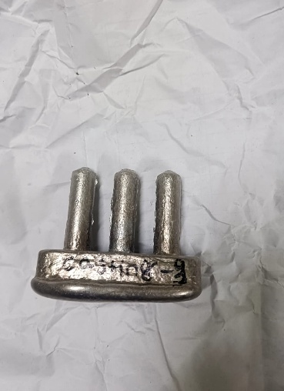 | 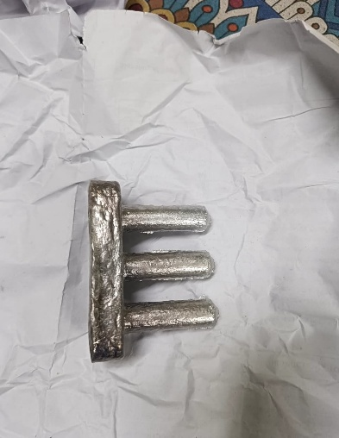
Al-15Si-1.5Al2O3-2TiB2 | Al-15Si-1Al2O3-3TiB2
Figure 9: - Cast composite sample

POLISHING:

Polishing of the prepared Al–Si composite specimen was carried out to obtain a smooth and mirror-like surface for microstructural examination. Initially, the sample was ground using different grades of emery papers (e.g., 220, 400, 600, 800, 1000, and 1200 grit) to remove surface irregularities and scratches. Grinding here refers to the process of smoothing the surface by rubbing it against abrasive emery papers.
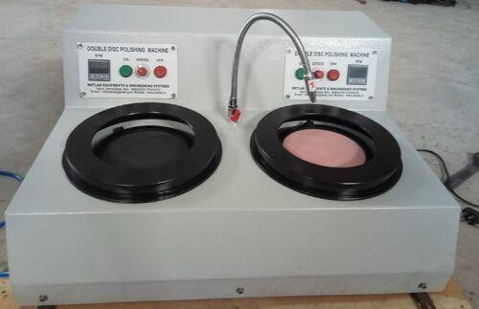
After emery polishing, the specimen was cleaned and then subjected to disc polishing using a cloth wheel. An alumina–water suspension was used as the polishing medium, as diamond paste was not used. Ethanol was used for cleaning between steps to remove debris and avoid contamination. The polishing process was continued until a smooth, scratch-free surface was achieved.
Figure 10: - disc polishing machine

MICROSCOPY:
Microstructures of the composites were observed under computerized optical microscope. The samples were polished using emery papers followed by disc polishing and etching for 5-7 seconds with freshly prepared Keller’s reagent (1%HF-1.5%HCl- 2.5%HNO3- 95%H2O).

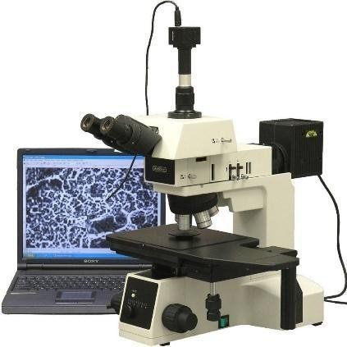

Figure 11: metallurgical microscope

HARDNESS TEST:
The Vickers hardness test is a method used to measure the hardness of materials. The Vickers test is often easier to use than other hardness tests since the required calculations are independent of the size of the indenter. The basic principle, as with all common measures of hardness, is to observe a material's ability to resist plastic deformation from a standard source. The unit of hardness given by the test is known as the Vickers Pyramid Number (HV) or Diamond Pyramid Hardness (DPH).
The Vickers hardness test involves indenting the test material with a diamond pyramid under controlled conditions.
- Ensure the surface is clean and flat.
- Set up the Vickers micro hardness tester, ensuring proper calibration.
- Apply the load 3Kgf to the diamond indenter on the material surface.
- Allow the indenter to dwell for 10 seconds to create an indentation.
- Measure the diagonals of the resulting indentation using a microscope.

Calculate the Vickers hardness number using the formula:
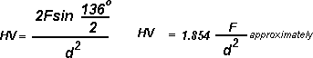
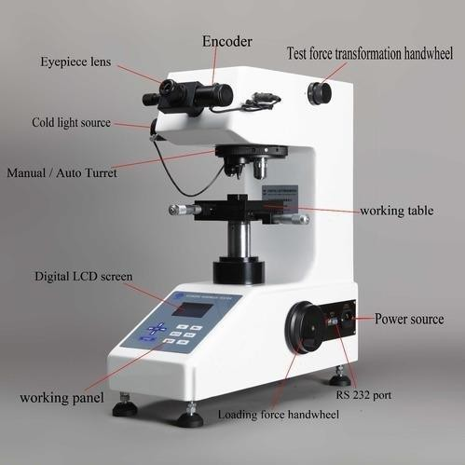

Figure 12: Vickers hardness test machine

DENSITY TEST:
The density of the specimens was measured with the help of a density tester. Care was taken such that the weight of the samples did not exceed above 20gm or below 10gm.The specimens to be measured were placed inside the machine turn by turn and the density was calculated by the formula:

Where:
Density = ^{𝐴}
𝐴−𝐵
(𝐷𝑤 − 𝐷𝑎) + 𝐷𝑎

A = Weight of the sample in air
B = Weight of the sample in water
𝐷𝑤 = Density of water (1gm/cm³)
𝐷𝑎 = Density of air (0.0012gm/cm³)

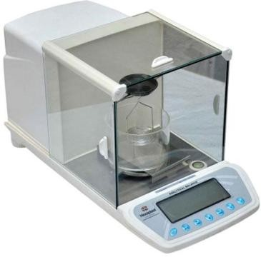
Figure 13: Density test apparatus

CHAPTER 4 RESULT AND DISCUSSION

DENSITY TEST:

Sample no. | Sample composition | Wt. in air (in gm) | Wt. in water (in gm) | Density (gm/cm³)
3 | Al-15Si-1.5Al2O3-2TiB2 | 2.0703 | 1.2970 | 2.6751
4 | Al-15Si-1Al2O3-3TiB2 | 2.0179 | 1.2722 | 2.7039
Table 5: Density table of Specimen

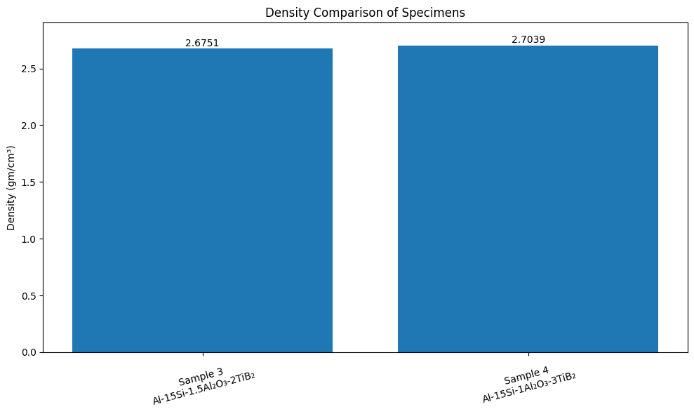

INFERENCE
- The results confirm that reinforcement type and proportion directly affect density.
- Sample 4 is more densified, indicating:
- Better microstructural compactness
- Reduced porosity
- Both samples show good processing quality, but Sample 4 is slightly superior.
Graph 1: Density of specimen

HARDNESS TEST:

Sample no. | Sample composition | Vickers hardness (HV 3)
3 | Al-15Si-1.5Al2O3-2TiB2 | 97.63±7.19
4 | Al-15Si-1Al2O3-3TiB2 | 50.69±5.37  Table 6: Hardness of Composites

Graph 2: Hardness of specimen

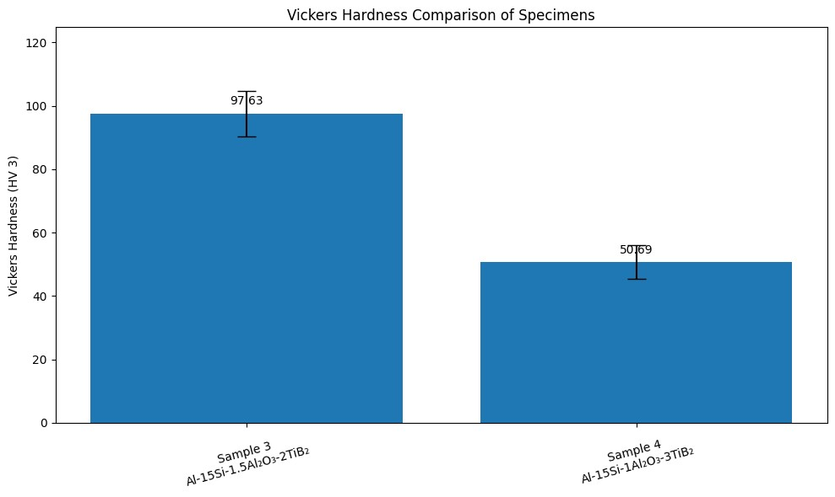
Graph 2: Hardness of specimen

INFERENCE
- Sample 3 shows significantly higher hardness than Sample 4.
- The hardness value of Sample 3 is nearly 1.93 times that of Sample 4TiB₂ also contributes to hardness improvement, but its effect is comparatively moderate.
- Sample 3 Shows Higher Hardness
Higher Al₂O₃ Content (1.5%)
Al₂O₃ is a very hard ceramic reinforcement.

SCANNING ELECTRON MICROSCOPE (SEM):
- Metallographic Sample Preparation
Since aluminum is ductile, standard grinding can easily push soft metal over hard reinforcement particles creating a "smeared" surface.
  - Sectioning: Samples are cut using abrasive SiC cut-off wheels with high-flow cooling to minimize thermal damage.
  - Mounting: Hot mounting with phenolic resin is standard, but cold mounting with epoxy is used for delicate or heat-sensitive composites to prevent structural alteration.
  - Grinding & Polishing:
    - Grinding: Sequential grinding using SiC papers with water lubricant.
    - Polishing: Final polishing uses diamond suspensions or colloidal silica to achieve a mirror-like finish.
  - Etching: To reveal grain boundaries and the matrix-reinforcement interface, samples are often treated with Keller’s Reagent.

Detailed SEM analysis using High-Definition Backscattered Electron imaging confirms the successful integration of reinforcements within the aluminum matrix. The phase exhibits a dual morphology consisting of fine hexagonal particulates and elongated acicular laths, which are uniformly distributed with minor instances of localized agglomeration as seen in sample. The sharp, clean interfaces between the bright particles and the dark-grey matrix indicate strong interfacial bonding and high chemical compatibility. Furthermore, the lack of visible porosity or processing defects suggests a high degree of densification, confirming the effectiveness of the fabrication route in producing a structurally sound metal matrix composite (MMC)."

Phase Contrast and Material Distribution
  - Aluminum Matrix: The dark grey, continuous phase represents the aluminum matrix.
  - TiB2 Reinforcement Particles: The TiB2 particles appear as bright, white, or light grey features scattered throughout the matrix. This brightness is due to the higher atomic number of Titanium (Z=22) compared to Aluminum (13), which reflects more electrons in the mode.
  - Particle Morphology: The reinforcement appears as a mix of small, nearly spherical or polygonal particulates and elongated, needle-like (acicular) structures. In some areas, these particles are distributed fairly uniformly, which is critical for consistent mechanical propertie

Sample.3: - Al-15Si-1.5Al2O3-2TiB2

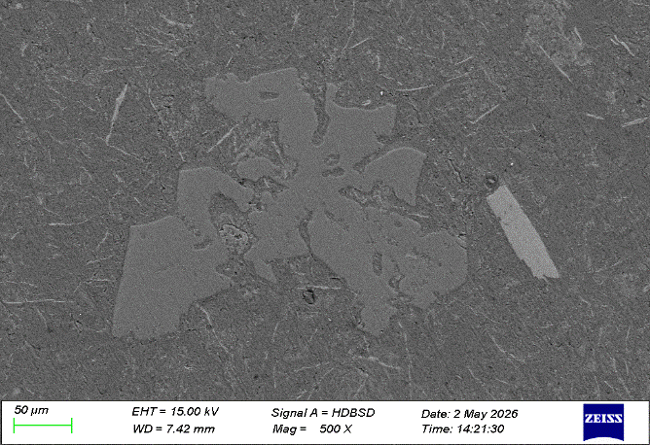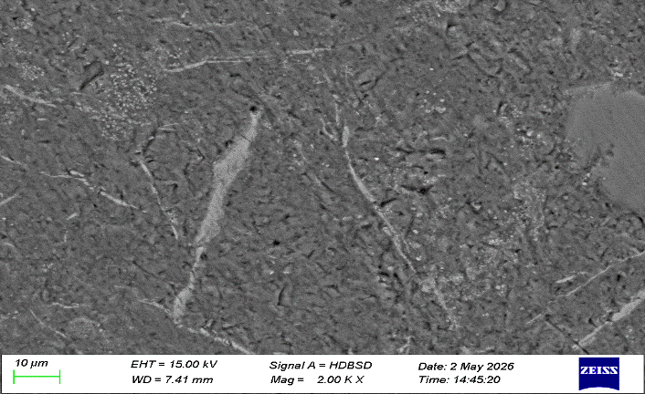

(500X)

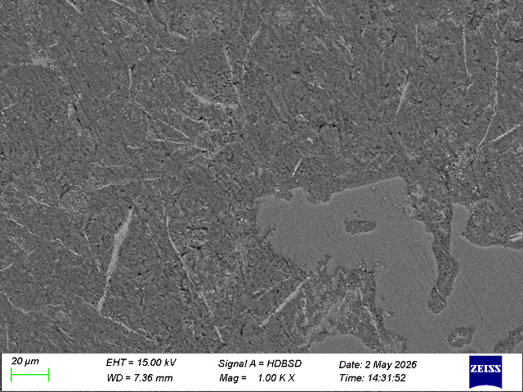
(2000X)
(1000X)

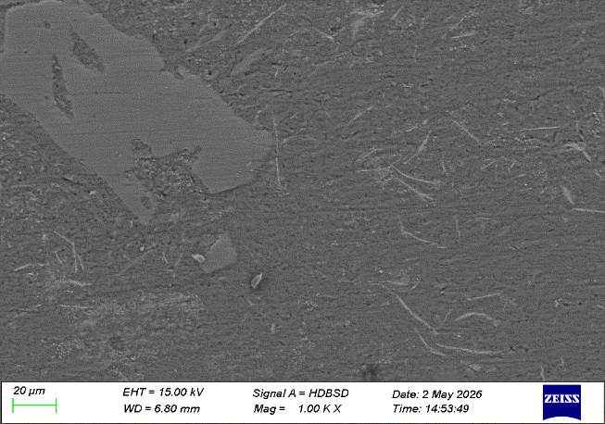
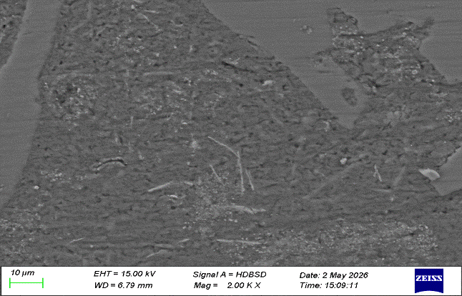
Sample.4: Al-15Si-1Al2O3-3TiB2
(1000X)
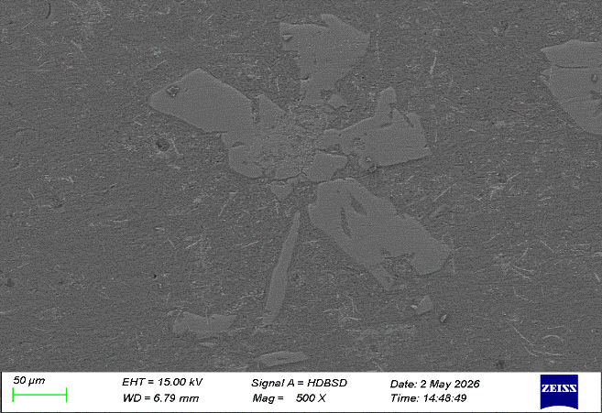

(500X)

(2000X)

- Conclusion: -
Based on the experimental investigation and microstructural characterization of the Al-Si- TiB₂-Al₂O₃ hybrid metal matrix composites, the following conclusions are drawn for this project:
  - Successful Synthesis via In-Situ Salt Reaction: Al-Si hybrid composites reinforced with TiB₂ and Al₂O₃ were successfully synthesized through the stir casting method. The in-situ salt-metal reaction between Potassium Titanium Fluoride (K₂TiF₆) and Potassium Fluoborate (KBF₄) proved effective in forming TiB2 particles directly within the molten alloy.
  - Microstructural Integrity and Phase Distribution: SEM analysis using High- Definition Backscattered Electron (HDBSD) imaging confirms the successful integration of reinforcements within the aluminum matrix. The TiB2 phase exhibits a dual morphology consisting of fine hexagonal particulates and elongated acicular laths. The sharp, clean interfaces between the bright reinforcement particles and the dark-grey matrix indicate strong interfacial bonding and high chemical compatibility.
  - Density Trends: The density of Al-Si hybrid composites increases with the addition of ceramic reinforcements, particularly TiB₂, due to its higher intrinsic density. However, slight variations in density indicate the influence of porosity and particle distribution.
  - Hardness Trends: The hardness of the composites generally increases with higher TiB₂ .

- Reference: -

  - Materials for engineering (3rd Edition), Author: J. W. Martin. Woodhead Publish limited.
  - Principle of metal casting, Authors: Richard W. Heine, Carl R. Loper and
C. Philip C. Rosenthal.
  - Composite Materials: Science and Engineering, Author: Krishna K. Chawla, Springer science & Business media.
  - Aluminium: Properties and Physical Metallurgy, Author: John E. Hatch (ASM International).
  - Physical Metallurgy, Author: Vijendra Singh (1st Edition), Standard publishers’ distributors.
  - Acharya, M., & Mandal, A. (2019). Individual and synergistic effect of gamma alumina (γ-Al2O3) and strontium on microstructure and mechanical properties of Al20Si alloy. Transactions of Nonferrous Metals Society of China, 29(7), 1353-1364
  - Bhowmik, A., Chakraborty, D., Dey, D., & Biswas, A. (2020). Investigation on wear behaviour of Al7075-SiC metal matrix composites prepared by stir casting. Materials today: proceedings, 26, 2992-2995.
  - S. M.I. M. S. D. Jasmina Petrovic, Characterization of Hybrid Aluminum Composites Reinforced with a/203 particles and walnut-shell ash, 2022.

